JVNMOBILEGIS Developer GUIDE
Prepared by: Khanh Le
Date: June 2008
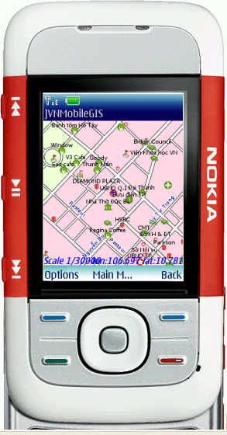

Objective
JVNMobileGIS’s objectives:
- Support popular standards of GIS
- Provide enough functionalities for normal users
- Compatible with all Java mobile devices
- Simple, easy to use

Technologies
- Java ME http://java.sun.com/javame/index.jsp
- MVC architecture. We recommend you to practice PureMVC at http://wiki.forum.nokia.com/index.php/Model-View-Controller_Architecture

Coding Standards

Java Class files
We follow Sun’s Java Coding Conventions (http://java.sun.com/docs/codeconv/) and recommend you follow it too.

Resource files
We use *.properties files for localization. The files are located at <jvnmobilegis_root>/res/l10n. Remember when you edit resource files, you must save them in “UTF-8 without BOM” encoding.
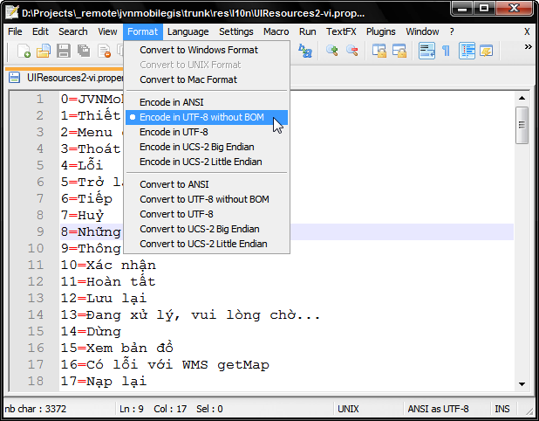
Figure 1. Text files encoding

Subversion Version Control
JVNMobileGIS use Google Code’s Subversion (SVN) for source code control. To checkout SVN, you need to use a SVN client software:
- TortoiseSVN http://tortoisesvn.tigris.org/ (Windows)
- SmartSVN http://www.syntevo.com/smartsvn/ (All OS)
Follow instruction at http://code.google.com/p/jvnmobilegis/source/checkout to checkout JVNMobileGIS’s files to your computer.

Java file header
When you create a new Java file, include this paragraph in your file header:
/*
* $Id: UIController.java 235 2008-05-30 06:24:59Z phamvubinh123 $
* $URL: https://jvnmobilegis.googlecode.com/svn/trunk/src/org/javavietnam/gis/client/midp/ui/UIController.java $
* $Author: phamvubinh123 $
* $Revision: 235 $
* $Date: 2008-05-30 13:24:59 +0700 (Fri, 30 May 2008) $
*
* ====================================================================
*
* <COPYRIGHT_NOTICE>
*
* @version: <YOUR_FILEVERSION>
* @author: <YOUR_NAME>
* @Date Created: <YOUR_CREATED_DATE>
*/
Example:
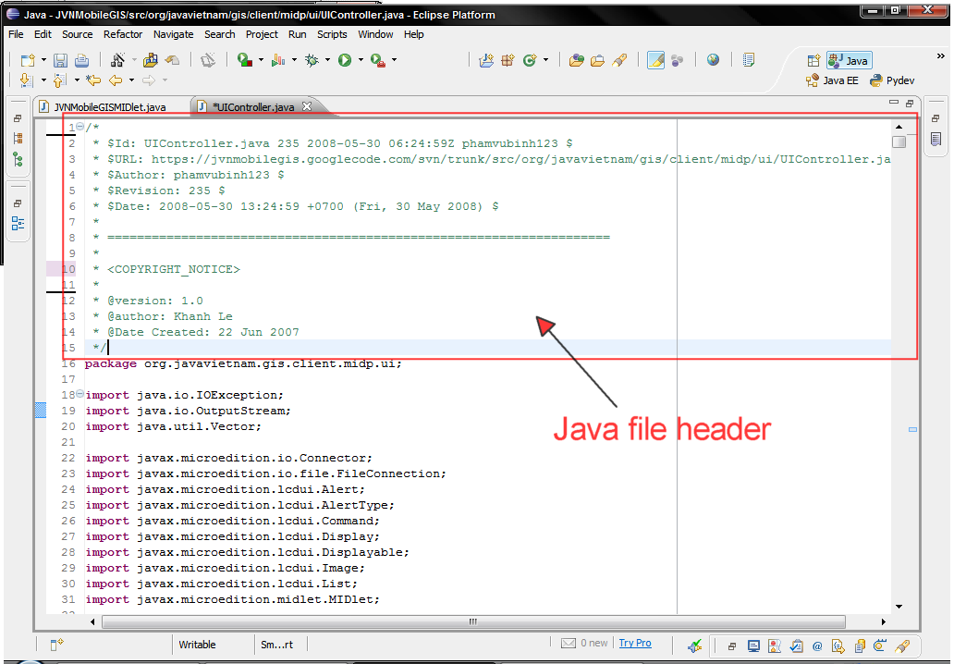
Figure 2. Java file header
SVN will auto modify the values inside $...$ every time you commit, so you don’t need to edit it yourself. For SVN to do that, you need to set SVN Properties values for your Java files:
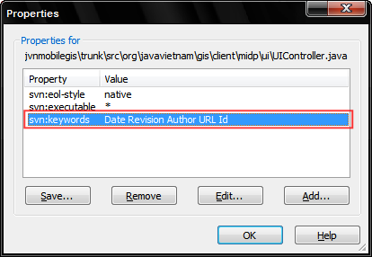
Figure 3. SVN Properties for Java files
Property: svn:keywords
Value: Date Revision Author URL Id

SVN commit
After finished coding and built JVNMobileGIS project successfully, you need to commit your changes to SVN (we recommend you commit all your changes at the end of the day). Please use this message format when you commit:
Issue: <issue_id>
Remarks: <what you changed and purpose of the change>

Development environments
You can build JVNMobileGIS in your favorite development environment in Windows or Linux. Basically, you have 3 development options below.

Option 1: ANT Build

Requirements
- Sun Java Wireless Toolkit http://java.sun.com/products/sjwtoolkit/
- Text Editor (e.g. Notepad++ http://notepad-plus.sourceforge.net/)
- Apache Ant http://ant.apache.org/
- Antenna http://antenna.sourceforge.net/

Instructions
- Unpack Apache Ant and include Ant’s bin folder in your PATH environment variable.
- Copy Antenna jar file into Ant’s lib folder
- Modify antenna-build.xml file in JVNMobileGIS root folder. Change value of ‘wtk.home’ property to Java Wireless Toolkit path in your machine
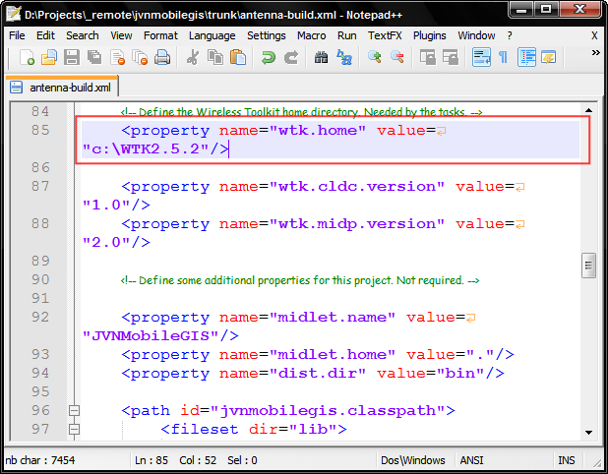
Figure 4. Edit antenna-build.xml file
- Open Command Prompt (in Windows) or Terminal (in Linux) and change directory to JVNMobileGIS root directory
- Enter ‘ant -buildfile antenna-build.xml’ to build and package JVNMobileGIS project
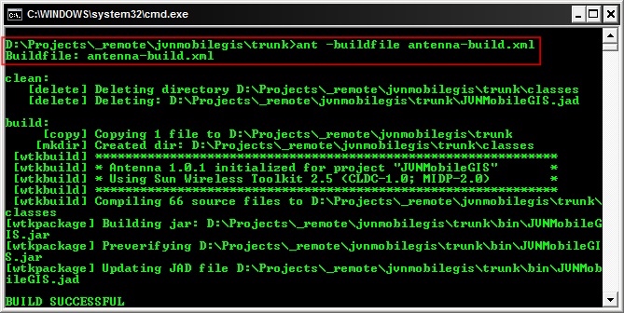
Figure 5. Ant build result
- Then you can enter ‘ant -buildfile antenna-build.xml run’ to run JVNMobileGIS

Option 2: NetBeans

Requirements
If you need a more powerful IDE for Java ME developement, I will recommend NetBeans.
Download and install NetBeans (with Mobility module) from http://www.netbeans.org. That’s all you need!

Instructions
- After installed NetBeans, check Tools > Java Platforms to see if you already have a J2ME platform. If not, add a platform from your Java Wireless Toolkit home.
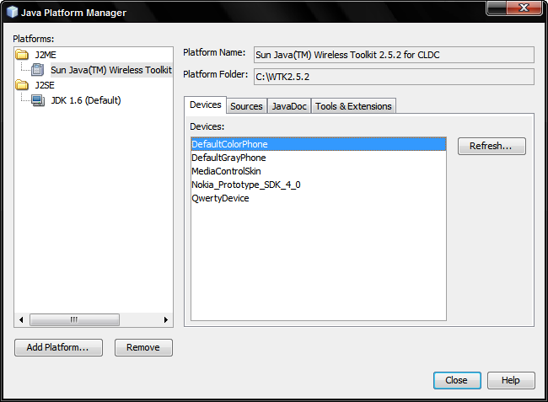
Figure 6. J2ME platform in NetBeans
- Click ‘Open Project’ icon or choose it from ‘File’ menu. You will see ‘Open Project’ dialog. Browser to JVNMobileGIS root folder and ‘Open’ it.
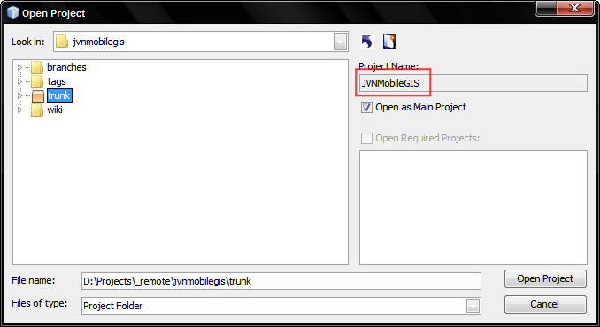
Figure 7. Open Project dialog
- If your J2ME platform is different from JVNMobileGIS’s configured platform, you will see a warning about ‘Reference Problems’
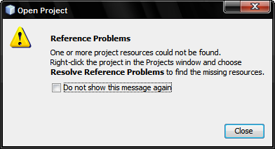
Figure 8. Reference Problems warning
- Don’t worry, you can right-click on JVNMobileGIS project at ‘Projects’ view and choose ‘Resolve Reference Problems’
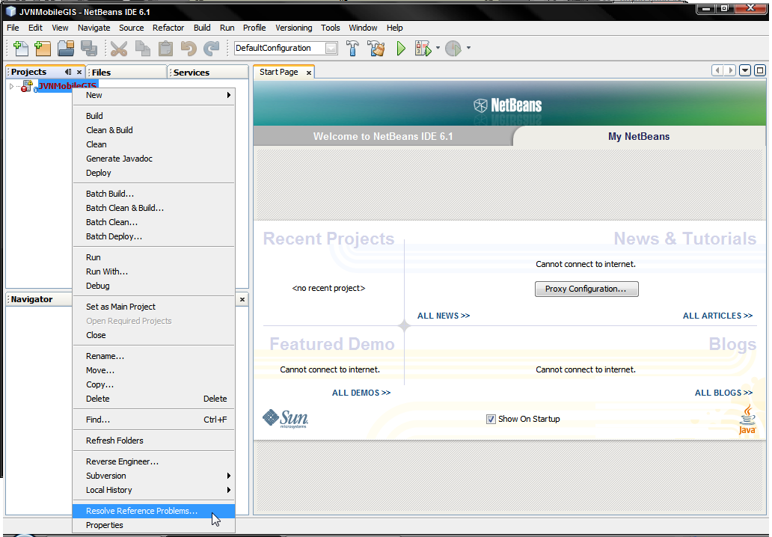
Figure 9. Resolve Reference Problems menu
- You will see the listed problem of JVNMobileGIS project, click ‘Resolve…’ button and choose the correct reference. The problem will be solved.
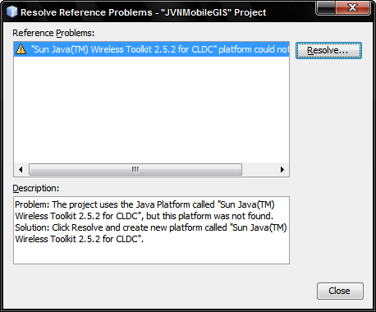
Figure 10. Resolve Reference Problems dialog
- If there is no problem or error, you can ‘Build’ and ‘Run’ JVNMobileGIS project in NetBeans by clicking on ‘Run’ icon or from ‘Run’ menu.
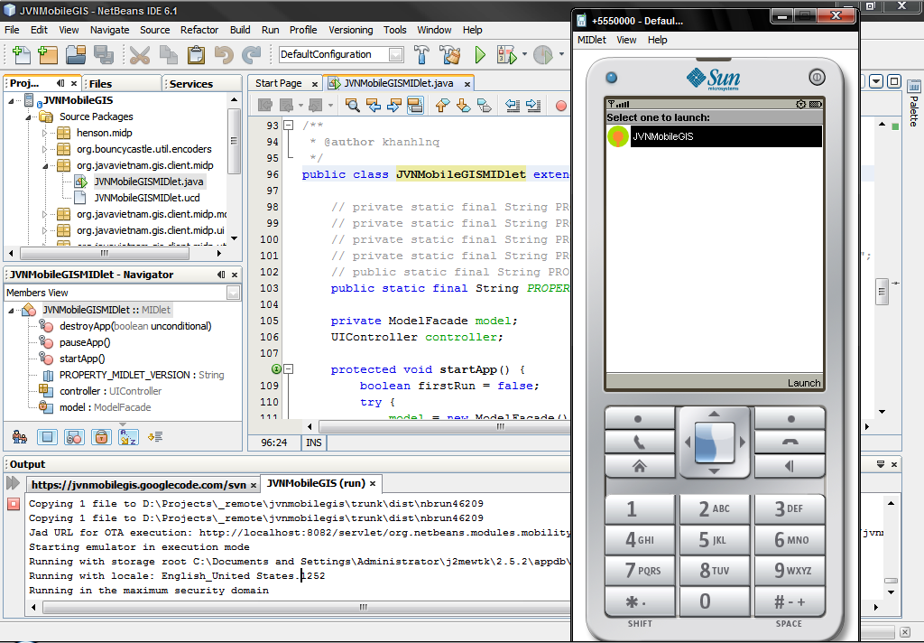
Figure 11. Run JVNMobileGIS in NetBeans
- You can use other powerful features of NetBeans, such as: debugging, UI design.

Option 3: Eclipse

Requirements
- Sun Java Wireless Toolkit http://java.sun.com/products/sjwtoolkit/
- Eclipse http://www.eclipse.org/
- EclipseME plugin http://eclipseme.org/

Instructions
- Follow EclipseME instruction (http://eclipseme.org/docs/index.html) to configure your J2ME settings in Eclipse. Make sure you imported J2ME devices to Eclipse.
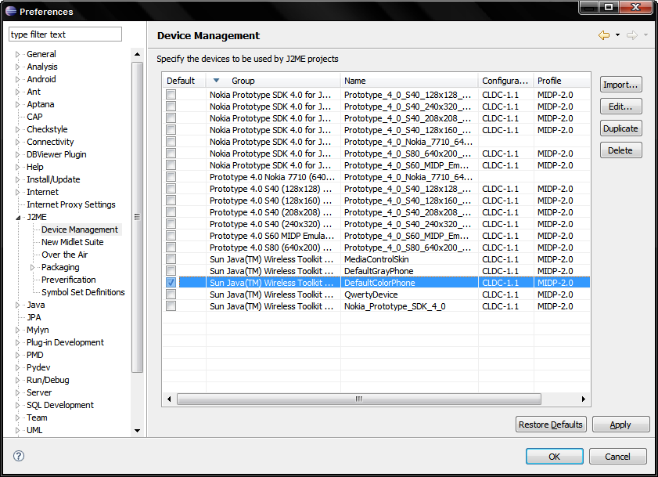
Figure 12. J2ME Devices in Eclipse with EclipseME
- Choose File > Import… and choose ‘Existing Projects into Workspace’, click ‘Next’.
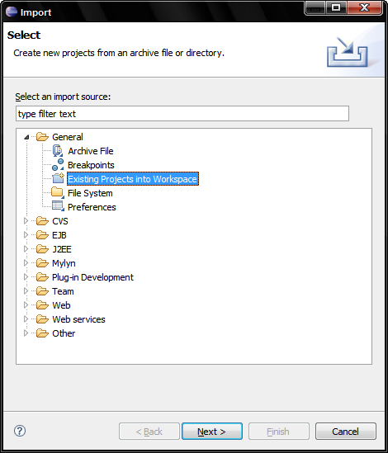
Figure 13. Eclipse Project Import dialog
- Browse to JVNMobileGIS root folder, click ‘Refresh’ to see ‘JVNMobileGIS’ in projects list, select it to import. Click ‘Finish’.
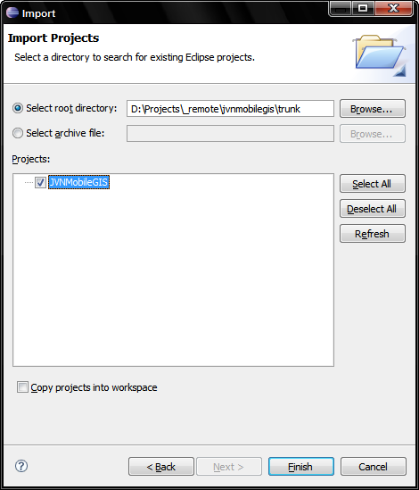
Figure 14. Select project to import
- Now check your project properties, right-click on JVNMobileGIS in ‘Package Explorer’ and choose ‘Properties’. In ‘J2ME’ node, you need to select device for JVNMobileGIS project like below.
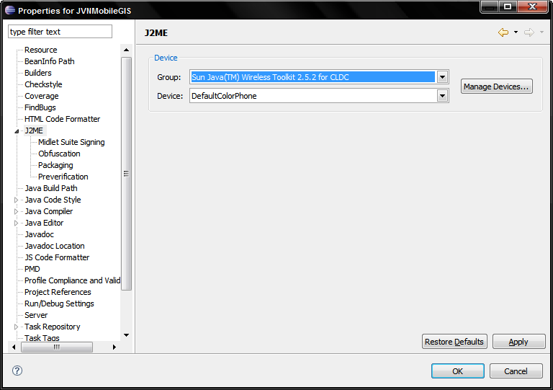
Figure 15. J2ME Settings for JVNMobileGIS project
- Choose Run > Open Run Dialog… Create ‘New’ configuration to run JVNMobileGIS in ‘Wireless Toolkit Emulator’ node like below.
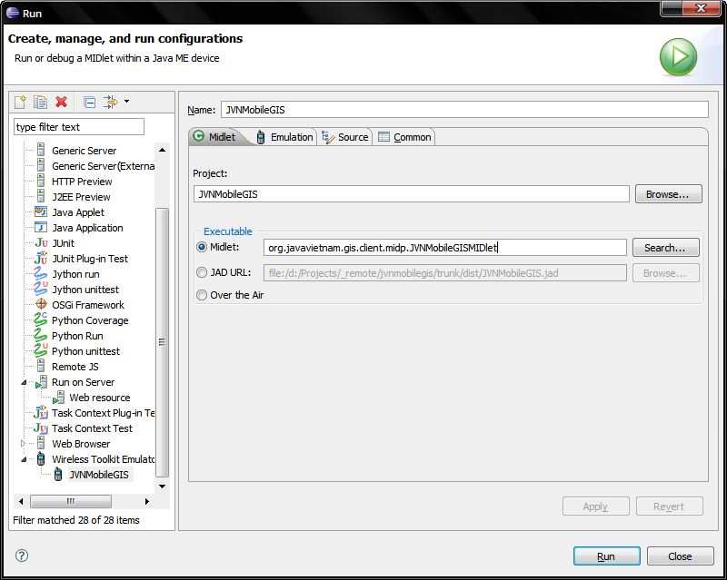
Figure 16. Run configuration for JVNMobileGIS
- After that, click ‘Run > JVNMobileGIS’ to run JVNMobileGIS in Eclipse
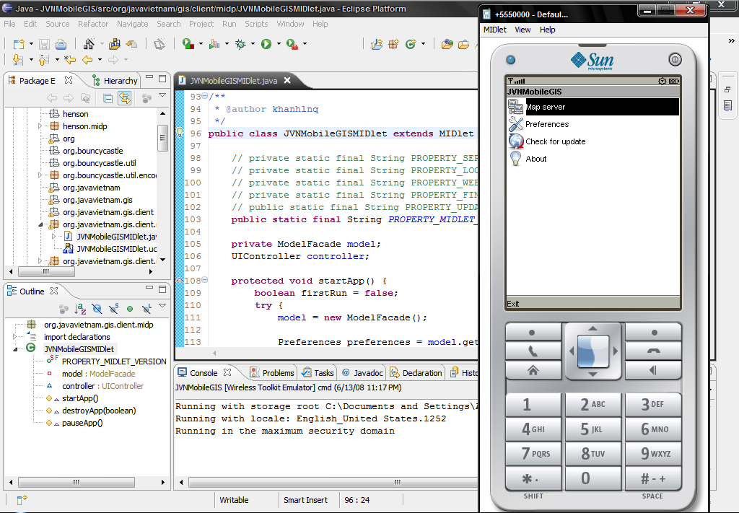
Figure 17. Run JVNMobileGIS in Eclipse

Generate executable files
You can also convert JVNMobileGIS into executable file (EXE file, for Windows only) for easier demonstration.
- Open Command Prompt and change directory to ‘bin’ folder in JVNMobileGIS root folder
- Enter ‘Midp2Exe.exe -jad JVNMobileGIS.jad -jar JVNMobileGIS.jar’. It will generate JVNMobileGIS.exe file.
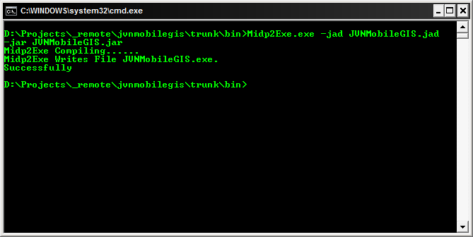
Figure 18. Command to generate JVNMobileGIS.exe
- Now you can run JVNMobileGIS.exe without Java Wireless Toolkit or JRE.
Note: MidpRuntimeDLL.dll must be exist in same directory with JVNMobileGIS.exe
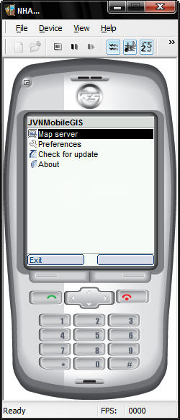
Figure 19. Run JVNMobileGIS.exe

Support
For more information, please go to:
- FAQ - http://code.google.com/p/jvnmobilegis/wiki/FAQ
- Discussion forum - http://groups.google.com/group/JVNMobileGIS

